Java Homework 1

1.Write an application program that inputs three integers from the user by using input dialog and displays the sum, average, product, smallest and largest of the numbers on the message dialog.

Case I: without defining any function in your program except the main function.

Case II: define “smallest” and “largest” function in your program.

1. Please describe how the Java application program is executed by usig this problem.  
   >javac hw1_1.java 生成byte code  
   >java hw1_1執行bytecode，轉成machine在local端看得懂的machine code  
     
   >javac hw1_2.java生成byte code  
   >java hw1_2執行bytecode，轉成machine在local端看得懂的machine code
2. Please describe the differences between these two cases in your programs.  
   case1:寫在main內的程式直接使用就可以，不需要呼叫method  
   case2:如果要在main之外再創function，仍要由身分是public static的main去呼叫method，所以額外定義的function也要是static

2. Write a **Java applet** programs that draws a house, some trees, the moon and etc

To form onelandscape.( try your best)

Use the following drawing methods defined in the **Graphics** class.

(You may reference textbook §13.3 §13.5 ~§13.7 p601~622 I will teach you later, but you may try and use these methods first)

drawLine(x1,y1,x2,y2);

drawRect(x,y,w,h);

drwaRoundRect(x,y,w,h,aw,ah);

drawOval(x,y,w,h);

drawstring(“…”,x,y);

drawPolygon(…);

drawImage(…);

…

The house may be like:

The house may be like:

Note: You might want to draw a house that is much more interesting than the one shown here.

Please describe how the Java applet program is executed by using this problem.

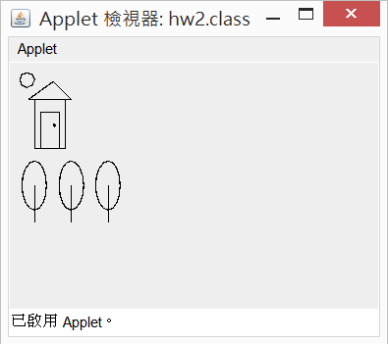

>javac hw2.java

Then define a html file for running applet program. 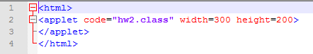

>appletviewer house.html

3. Write an application program that determines the change to be dispensed from a vending machine. An item in the machine can cost from 25 cents to one dollar, in 5-cent increments (25, 30, 35, …90,95,100), and the machine accepts only one single dollar bill to pay for the item. For example, a possible sample dialog

might be:

Enter price of item:

(from 25 cents to one dollar, in 5-cent increments): 45

You bought an item for 45 cents and gave me one dollar.

So your change is

2 quarters,

0 dime, and

1 nickel

Note:

Penny=1 cent= 0.01 dollar

Niclel= 5 cents= 0.05 dollar

Dime= 10 cents=0.1 dollar

Quarter=25 cents=0.25 dollar  
 >javac hw3.java  
 >java hw3

1. Write an application program that read a file name from the input dialog. The file name should has one . (dot) character in it, separating the file name from the file extension. Retrieve the file extension and output it on the message dialog.

For example:

If the user inputs JavaTest1.html, you should output the file extension is ***html****.*

If the user inputs Test2.java you should output the filet extension is ***java***.

>javac hw4.java  
>java hw4

1. Please outline and list the drawing methods defined in the class Graphics.

(請整理及列出在class Graphics中和畫圖相關的函數)

